## [Juliette Bricker](https://juliettebricker.ca/)

Top of Form

Bottom of Form

# Assessing the usability and desirability of a novel 360° map projection for Tourism in Parks

**Short description:**

After learning that no map is completely accurate, Juliette wanted to build a map that used distortions to its benefit. The Vienna 360° is an experimental map that is projected with its users and environment in mind. Hung in a circle, this map depicts a panoramic-like visual that shows what’s in every direction from where you stand! Whichever direction you choose to go after visiting this installation, you will know what sites await you in the beautiful city of Vienna. This will be the first official build of the concept with hopes of adding more accessibility features and sustainable materials in future versions.  
  
Concept and design:

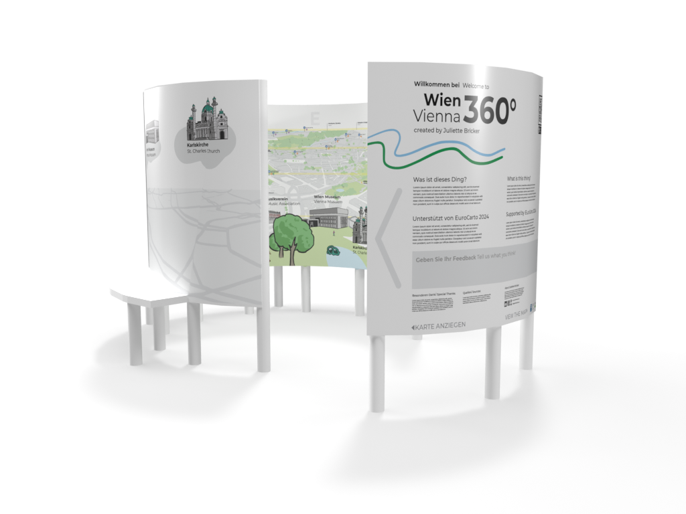

Top of Form

Bottom of Form